Rédaction

Invente une histoire de quelques lignes en t’inspirant d’une des illustrations de Chris Van Allsburg.

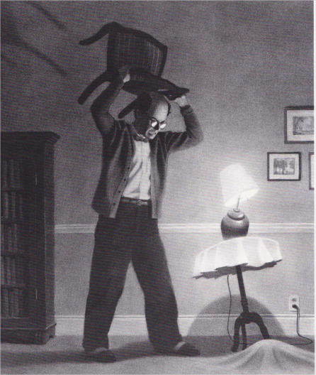 | 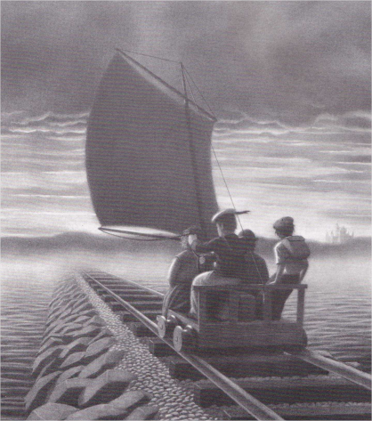
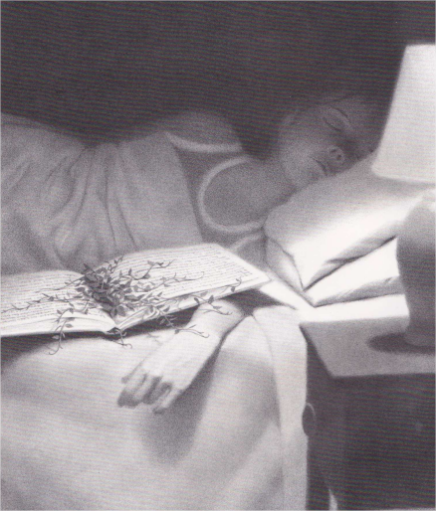 | 





